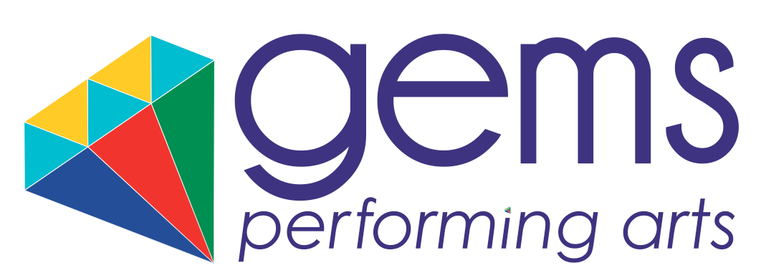

Gems Performing Arts will be holding auditions Saturday 10th September 2016 to join award-winning Sapphire Youth Dance Company!

Sapphire YDC represented London & Kent in the UK Make Your Move Dance Competition after winning their heats. They have performed at:
Her Majesty's Theatre - West End
London Palladium - West End
Sydenham Arts Festival
Crystal Palace Overground Festival
The Albany Theatre, Deptford
Greenwood Theatre
IndiGo2

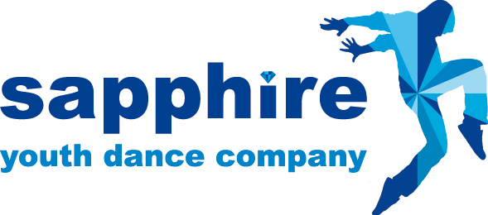

Mission Statement:
We aspire to be the No.1 Youth Dance Company in South East London. We will strive to identify genuine talent, to enhance each student's performance skills in a supportive environment and to allow every student to wholly fulfill their potential as a dancer.

Description:
Sapphire is specifically designed for children ages 10 – 16, nurturing talent from an early age. We will focus on different dance techniques, such as partner work, floor work, strength and flexibility. We want to engage with the children creatively and devise processes where children can input their ideas choreographically. We also want to introduce the company to different dance styles and a variety of music, visual arts etc. We aim to do this by bringing in dance practitioners and professionals in the industry. We aspire to creating exciting opportunities for the children, both within the local communities and around the UK.

The company meet every Saturday at their base at Sydenham High School from 12 - 1.30

To audition you must be over 10 years and under 17 years old on 1 September 2015. You
will preferably live in South East London as our current base is Sydenham High School, SE26 6BL

- You must have some experience in one or two dance styles, enjoy performing and making up dances with other young people
- Be keen to try out dance techniques and styles new to you
- Enjoy working as part of a team and have the ability to work well with others.
- You must be enthusiastic and committed and have the support of your parent or guardian!

If chosen for Sapphire Youth Dance Company you must:

• Be able to get to weekly classes and rehearsals at the company’s usual base
• Be available for any extra rehearsals with guest choreographers. This is really important as they are the most exciting part of being in the company!
• Be able to take part in performances throughout the year, which may involve being available all day for travel and rehearsals.
• We realise that people get ill or or may have other unavoidable events, but you need to show commitment to stay in the company. If you miss rehearsals you may not be able to take part in performances.

What does it cost?

If you are chosen to join SYDC for 2015-16 you will be asked to pay either £225 for the whole year, or you can pay in installments of £80 per term.

How do I apply?

• Email or post your completed audition application form (see below) to emma@gemsperformingarts.com /
22 Horniman Grange 62 London Rd SE23 3HQ

• The closing date for all applications is 10th September 2016. The earlier you return your form the more likely you are to get a place at the audition.

The Auditon:

The audition will be informal and friendly. It is a chance for us to meet the children and get an idea about what they could bring to the company. Please come in comfortable dancewear and bring water.

Deadline is September 10th 2016

Children will then be emailed with an audition date and time.

SAPPHIRE YOUTH DANCE COMPANY AUDITION APPLICATION FORM

Office: 22 Horniman Grange,
62 London Rd, SE23 3HQ
M: 07946 176 452
E: emma@gemsperformingarts.com
www.gemsperformingarts.com

Child Name: ____________________________________________________

Parent/Guardian Name: _________________________________________________

Address: ________________________________________________________________________________________________________

Email: ______________________________________________________________ Mobile: _________________________________

DOB: _________________________ Age: ____________ (over 10 and under 17 on 1.9.16)

School: _______________________________________________

Do you have any disability, pre-existing medical conditions or previous injuries that might affect your ability to participate fully? Please let us know if there is any support we could offer

_____________________________________________________________________________

_____________________________________________________________________________

Where did you hear about the auditions?

Gems Performing Arts Teacher Flyer Website Word of Mouth

Other __________________________________________

Your information will be added to our database for the purpose of administering the auditions. We may also like to send you information in the future about other Gems Performing Arts events.

By Post By Email Do Not Send Anything

I give consent for my child to audition.

Signed _________________________________________________

Print Name _________________________________________

